STUDENT NAME: PERIOD: DATE:
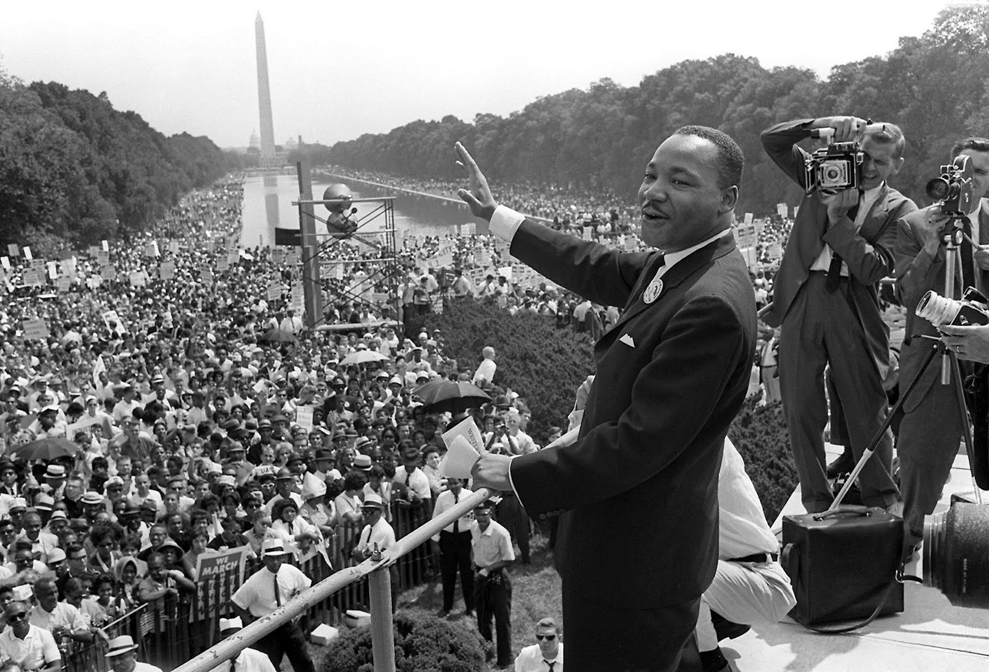

Civil Rights Movement

Webercise

The Civil Rights Movement

Before the Movement
Click on the interactive timeline link to answer the following questions.
Civil Rights Chronology

Find the year 1863 and 1865 on the Interactive Timeline.
What did President Lincoln do in 1863, and what did Congress do in 1865 to assist the slaves?

What challenges did African Americans face after slavery was abolished (1865)? And why do you think these challenges were significant to the Civil Rights Movement?

The Black Codes and Discrimination
Click on the article link to answer the following questions.
Exploring The Issues of Jim Crow

What were the Jim Crow Laws?

List some characteristics of the law and how did the laws effect people of color?

What Supreme Court case strengthened discrimination? And established “Separate but Equal?”

What was the meaning behind Separate but Equal? And was the meaning true?

Freedom Riders and Activists
Click on the link to the interactive map to answer the following questions.
Freedom Riders Map

Who were the Freedom Riders and what were their goals?
What challenges did the Freedom Riders encounter?

James Farmer

James Farmer was a Freedom Rider; how did he play a critical role in the Civil Rights Movement?
Brown vs. Board of Education
Click on the link to watch the video to answer the following questions.
Brown v. Board of Education Video
Why was Thurgood Marshall a significant figure during the struggle for Civil Rights?
How did the Supreme Court ruling help spark the Civil Rights Movement?
The Continuing Struggle for Civil Rights
Click on the link to watch the video to answer the following questions.
Still Segregated Video
- After watching the “Still Segregated” video, how is inequality still active today after the Civil Rights movement?

- What are possible solutions to help relieve this issue?

