Student Name: Period:

Civil Rights Movement Guided Notes

Important Supreme Court Cases and legislation before the Civil Rights Movement. | What was the ruling in Dred Scott v. Sanford (1857)?  What legislation did Lincoln sign that freed the slaves?  What did the 13th and the 15th Amendment guarantee?  Why was the Civil Rights Act of 1875 Struck down? | 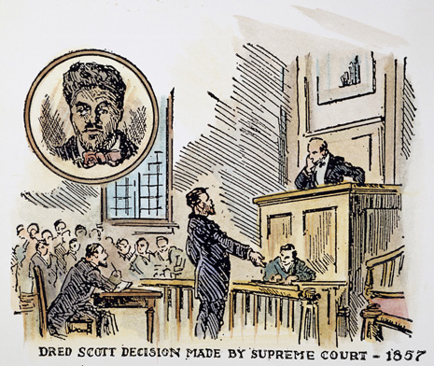
Discriminatory Practices | What were Jim Crow Laws?  What areas were colored and whites separated from?  What was the ruling in Plessy v. Ferguson (1896)? | 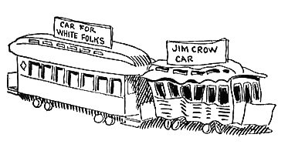
Important Events During the Civil Rights Movement | What was the Supreme Court ruling in Brown v. Board of Education (1954)?  What did Rosa Park’s action lead to?  What happen in Greensboro, N.C. in 1960? And why was it important?  What was the impact of the march in Selma, Alabama in 1965?  What did the Civil Rights Act of 1964 and 1968 guarantee? | 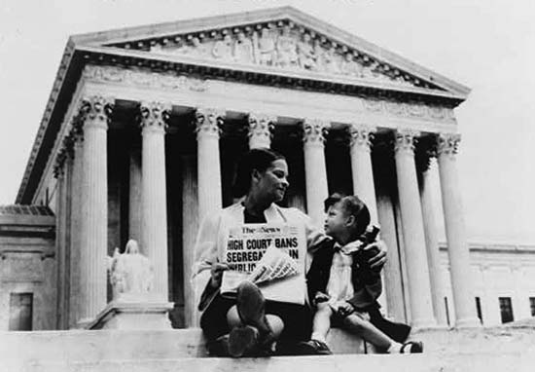
Civil Rights Activists | Describe the Role of each Activist  Martin Luther King Jr.  Philip Randolph  Malcom X  Thurgood Marshall  James Farmer  Rosa Parks | 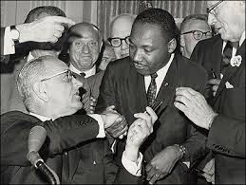
The Continuing Fight | What was CA Proposition 209?  What was the Supreme Court Ruling in Regents of University of CA v. Bakke?  What civil or equal rights issues can you think of that is occurring today? | 